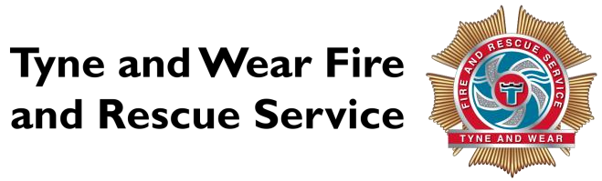
Gifts and hospitality received 1 April 2024 to 31 March 2025

Declaration Category Date |  | Gift/hospitality received Donated by |  | Accepted Destination |  | Reason for the offer
22/04/2024 | Category B: Trivial Gift - Under £10 | Biscuits and tea bags | Member of the public | Accepted | Consumed | Appreciation for the job the crews do for the public
25/04/2024 | Category C: High Value Gift - Over £10 | £20 john Lewis Gift Voucher | The Fire Protection Association | Accepted | Donated | Attending and presenting at FPA Fire Safety and the sustainability of the built environment conference.
14/05/2024 | Hospitality | CIPFA Dinner place from Mazars | Mazars | Accepted | Attended | Networking Dinner
29/07/2024 | Category D: Cash Gift - Any amount | £10 in cash | Member of the public following S&W | Unable to return |  | Appreciation of the service
09/09/2024 | Category B: Trivial Gift - Under £10 | 6 packets of Lidl biscuits | Member of public | Accepted | Consumed | As a thank you following the attendance at an incident
18/10/2024 | Category B: Trivial Gift - Under £10 | Tray of donuts | Member of the public | Accepted | Consumed | Excellent service provided to the local community
18/08/2024 | Category C: High Value Gift - Over £10 | Two one4all cards balance of £85. | Unknown origin (posted to Station Charlie) | Unable to return | Donated to charity | unknown
19/12/2024 | Category B: Trivial Gift - Under £10 | Box of Roses Chocolates | Safe and Well Occupant (member of public) |  | Accepted | Consumed | Grateful for service and it's Christmas.
Gifts and hospitality received 1 April 2024 to 31 March 2025 continued

Declaration Date | Category Gift/hospitality received |  | Donated by Accepted |  | Destination | Reason for the offer
21/12/2024 | Category C: High Value Gift - Over £10 | 8 Boxes of Chocolates (Roses, Heroes, Celebrations, Quality Street) 1 tub of Barratts Favourites Sweets. | Member of the public | Accepted | Shared between watches and shared with NEAS | To say thank you for the wonderful work the emergency services do for the local community
23/12/2024 | Category C: High Value Gift - Over £10 | £50 Cash, 1 bottle of Veuve Clicquot Champagne, 2 bottles of white wine | Tesco - Trinity Square Gateshead | Accepted | Donated | Act of kindness
24/12/2024 | Category B: Trivial Gift - Under £10 | Celebrations Chocolates. | Member of the public. | Accepted | Consumed | Politeness, attention to detail of a crew during delivery of Safe and Well visit on Christmas Eve.
31/12/2024 | Category B: Trivial Gift - Under £10 | £10 cash donation | Member of the public | Accepted | Donated | For our services to the community

